### REGISTRATION FORM OF 17th GCBSS CONFERENCE 2025

**20-21 August 2025**

**ASTON DENPASAR HOTEL & CONVENTION CENTER, BALI**

**(IN-PERSON & ONLINE)**

http://gcbss.org /Registration-Payment.html

The 17th GCBSS will take place on **August 20-21, 2025, at the Aston Denpasar Hotel & Convention Center in Bali, Indonesia.** The event will be available both in-person and online. Please ensure that all participants email the completed Registration Form (in .doc, .docx, or .pdf format) along with the proof of payment receipt to admin@gcbss.org and kindly CC [register@gatrenterprise.com](mailto:register@gatrenterprise.com).

**SECTION 1: CONTACT INFORMATION**

|  |  |  |  |
| --- | --- | --- | --- |
| Paper ID Code: **For example,** CIMSSR-00201 | | | |
| Name that you would like to get printed on the certificate: | | | |
| Conference Title: 17th Global Conference on Business and Social Science, Bali, Indonesia. | | | |
| Whether to attend the Conference: € Yes € No | | | |
| Position (Professor/Associate Prof/Assistant Professor/Lecturer/PhD Student/Master Student/other): | | | |
| Complete Affiliation/Organization/University and Country Name:  (That you like to get printed on the certificate) | | | |
| Broad Field: **i.e.**, Accounting | | Are you willing to serve as a session chair:€ Yes € No | |
| Session Type:€ Oral Presenter € Poster € 3 Minutes PhD proposal € Visual Presenter (**ZOOM**) | | | |
| Telephone: | Mobile: | | Email: |
| Special Needs or Dietary Requirements: € Yes €No | | | |
| Fulltime Student ID Number of Your University (if applicable): | | | |
| Abstract/Paper Title: | | | |
| Paper Pages: | | Additional Page: | |
| Are you interested in joining the Conference Tour: € Yes € No | | | |
| Are you interested in attending the GALA Dinner & Networking: € Yes € No | | | |
| Are you interested in attending the Workshop: € Yes € No | | | |
| Are you interested in joining the Academic Discussion Session: € Yes € No | | | |

**Notes:**

1. A regular registration covers a paper of up to 8 pages, including all figures, tables, and references, with a line spacing of 1.5. If the Paper exceeds **8 pages**, authors must pay an additional fee of **USD 25.00** for each extra page.
2. If there are **more than two authors** for the manuscript, additional fees of **USD 50.00** will be required for each additional author.
3. For **extra certificates, co-authors must pay USD 100** for each certificate requested.

**SECTION 2: REGISTRATION FEES INFORMATION**

|  |  |  |  |
| --- | --- | --- | --- |
| **17TH GCBSS 2025 FEE SCHEDULE:** | **Early bird  Until: 28/03/2025** | **Standard Until:**  **30/05/2025** | **Late  Until: 18/08/2025** |
| Oral/Poster Presenter (Lead Author) / Co-author | USD 525 | USD 575 | USD 600 |
| Visual Presenter (**Through ZOOM**) | USD 425 | USD 475 | USD 500 |
| Full-Time Student (**Valid Student ID required**) | USD 425 | USD 475 | USD 500 |
| Additional Paper (by the same Presenter) | USD 325 | USD 350 | USD 375 |
| Attendee (Without abstract/Paper) | USD 300 | USD 325 | USD 350 |
| Online Attendee (Without abstract/Paper) (**Through ZOOM**) | USD 100 | USD 100 | USD 100 |
| **Additional Events for 17th GCBSS Delegates:** |  |  |  |
| Academic Discussion Session on 20 August 2025 | FREE | FREE | FREE |
| GALA Dinner & Networking on 20 August 2025 | FREE | FREE | FREE |
| Workshop on Publishing in High Impact Factor **(ABS & ABDC)** Indexed Journals on 21 August 2025 (IN-PERSON & ONLINE) | FREE | FREE | FREE |

## GATR/GCBSS Policy:

* A lecturer who is also a student will not qualify for the student rate.
* Full-time students must provide a valid student ID card and a letter of recommendation from the Dean.
* [Daily Market Conversion Rate applies to all USD prices.](https://www.google.com/search?q=usd+to+rm&rlz=1C1JZAP_enMY721MY721&oq=usd+to+rm&aqs=chrome..69i57j0j35i39j0l3.2062j0j7&sourceid=chrome&ie=UTF-8)
* **Service and transfer fees are not included in the prices** **mentioned above.**

Registration fee for Oral/Poster/ Student Presenter Included:

### Admission to the welcome reception and all sessions:

* Academic Discussion Session
* Conference KIT
* Printed presenter certificate with an official seal.
* Printed brief Program Schedule.
* E-Abstract Publication & Proceeding CD with ISBN
* **Journal publication fees** (**Sponsored by GATR**)
* Workshop on Publishing in ABS & ABDC indexed Journals.
* Two coffee breaks each day.
* International Buffet lunch daily
* GALA Dinner & Networking
* Free GCBSS Membership for 12 months.

Registration fee for Visual/Online Presenter Included:

### Admission to the welcome reception and all sessions:

* Presenter E-certificate with an official seal.
* E- Abstract Publication and Proceeding with ISBN
* Abstract Video publication on the Official Channel
* **Journal publication fees (Sponsored by GATR)**
* Brief E-Program Schedule.
* Workshop on Publishing in ABS & ABDC indexed Journals.
* Academic Discussion Session
* Free GCBSS Membership for 12 months.

Registration fee of Attendee Included:

### Admission to all sessions:

* Participation Certificate with an official seal
* E-Abstract Publication & Proceeding CD with ISBN
* Printed brief Program Schedule.
* Workshop on Publishing in ABS & ABDC indexed Journals.
* Free GCBSS Membership for 12 months.

Registration fee of Online Attendee Included:

* Participation E-certificate with an official seal.
* E-brief Program Schedule.
* Workshop on Publishing in ABS & ABDC indexed Journals.

**SECTION 3: PAYMENT INFORMATION**

**OPTION 1**

**Bank Deposit / ATM Transfer / Online Transfer / Telegraphic Transfer** in the Company's official account.

**Please Visit** [**http://gcbss.org/Registration-Payment.html**](http://gcbss.org/Registration-Payment.html)**.**

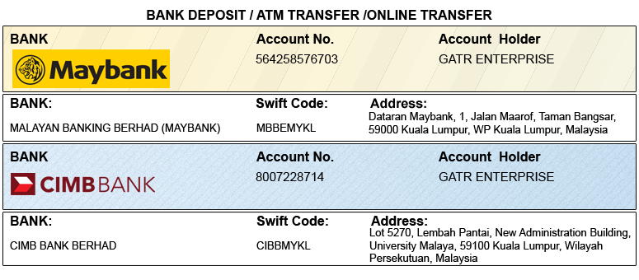

**OPTION 2**

**Credit Card /Debit Card/PayPal/2Checkout Account** to GATR 2checkout official account. **Registered official email**: info@gatrenterprise.com

**Please visit** [**http://gcbss.org/Registration-Payment.html**](http://gcbss.org/Registration-Payment.html)

**Note:** *Please remember to include your Abstract/Paper ID for payment tracking. A 5% transaction fee will apply to credit card payments..*

**PRIVACY POLICY:**

The Global Academy of Training & Research (GATR) Division is committed to protecting your personal information. The information we collect will only be used to fulfill your order, and we will not sell or share your information with anyone.

**CANCELLATION POLICY:**

You can cancel your registration without penalty if we receive your written cancellation request up to and including 45 days before the start of the Conference. If the request is received between 44 and 25 days before the start of the Conference, a credit voucher will be issued for less than 50% of the registration fee. Unfortunately, there will be no refunds or credits for cancellation requests received less than 25 days before the event begins. Please note that the Global Conference on Business and Social Science is not liable for any changes in the program, date, content, speakers, or venue.

**PLEASE NOTE:** Original receipts will be emailed to registered guests before the Conference for claim purposes.

|  |  |  |  |
| --- | --- | --- | --- |
| **Declaration:** I agree that I cannot claim back the registration fee I paid under any circumstance. | | | |
| **SIGNED:**  **(or write your name here)** |  | **DATE:** |  |